APPLICATIONS OF PROJECT MANAGEMENT TOOLS IN AUTOMOBILE INDUSTRY

Name
Institutions of affiliations
Course
Date

A motor vehicle is being designed and manufactured as part of this project. It employs a production process similar to that of Toyota. The following steps must be followed to ensure that the final product meets automotive quality standards: Numerous factors, including material costs, labor costs, and others, influence product pricing. The project's progress will be tracked both during and after completion. (Fernando, et al. 2018). In addition, the gross profit margin on automobile sales is included. The purpose of this essay is to make a theoretical as well as a practical contribution. Kick-off meetings, activity lists, progress meetings, and project management baseline plans are all common project management approaches. In addition, toolkits are the most often used technique as detailed in the chart below
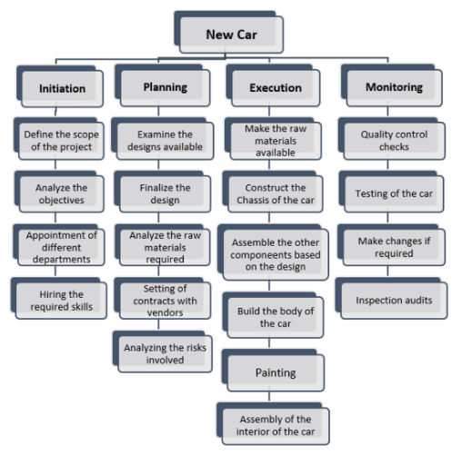
To gain a complete grasp of the breadth and complexity of their business, project managers rely on knowledge bodies as "best practice" standards. It covers innovative techniques that arise within the profession, as well as well-established traditional practices. A firm might utilize this survey to learn about the common procedures employed by other businesses (as a benchmark). These challenges will be addressed by schools that teach and train people in project management (Kerzner, 2019). These benchmarking approaches may be used by businesses seeking a competitive edge over their competitors. In the subject of project management, project management methodologies are always evolving. Sustainable manufacturing is becoming increasingly popular as society's demand for long-term sustainability grows. While the majority of sustainability frameworks are qualitative in character and focus on discussion of environmentally friendly materials and processes, there are a few notable exceptions to this rule: The analysis illustrates how material selection in production may be estimated statistically in order to achieve environmental objectives.

References
Fernando, Y., Walters, T., Ismail, M. N., Seo, Y. W., & Kaimasu, M. (2018). Managing project success using project risk and green supply chain management: A survey of automotive industry. International Journal of Managing Projects in Business.
Heigermoser, D., de Soto, B. G., Abbott, E. L. S., & Chua, D. K. H. (2019). BIM-based Last Planner System tool for improving construction project management. Automation in Construction, 104, 246-254.
Kerzner, H. (2019). Using the project management maturity model: strategic planning for project management. John Wiley & Sons.
Petrillo, A., De Felice, F., & Zomparelli, F. (2019). Performance measurement for world-class manufacturing: a model for the Italian automotive industry. Total Quality Management & Business Excellence, 30(7-8), 908-935.

